IST 707 – Homework 6

Handwriting Recognition

1 Introduction 2

2 Analysis & Models 3

2.1 About the Data 3

2.2 Data Processing 4

2.3 Exploratory Data Analysis 5

2.4 Models 8

2.4.1 Model Training and Testing Strategy 8

2.4.2 Decision Tree Models 8

2.4.3 Naïve Bayes Models 9

3 Results 12

3.1.1 Decision Tree Models 12

3.1.2 Naïve Bayes Models 14

3.1.3 Model Comparison 17

3.1.4 Kaggle Submission 17

4 Conclusions 18

# Introduction

The U.S. Constitution mandates that a census be taken every ten years to count all citizens and non-citizens living in the United States. Responding to the census is mandatory because getting a complete and accurate population count is critically essential. An accurate count of the population serves as the basis for fair political representation and plays a vital role in many areas of public life.

The census tells us who we are and where we are going as a nation and helps our communities determine where to build everything from schools to supermarkets and from homes to hospitals. It enables the government to decide how to distribute funds and assistance to states and localities. It is also used to draw the lines of legislative districts and reapportion each State's seats in Congress (Our Censuses, n.d.)

The most significant part of the census is collecting the census surveys and documenting the responses, explicitly documenting the handwritten census surveys. Survey processing is a humongous task that brings an opportunity for computers to read and recognize handwritten text. We will be exploring statistical methods which can help read the handwritten text. We will be analyzing only the handwritten numbers in our analysis.

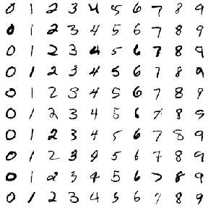

# Analysis & Models

## About the Data

We will be using an image database called MNIST. (MNIST DATABASE, n.d.) The MNIST database was constructed from the National Institute of Standards and Technology's Special Database 3 and Special Database 1, containing binary images of handwritten digits. NIST initially designated SD-3 as their training set and SD-1 as their test set. However, SD-3 is much cleaner and more comfortable to recognize than SD-1. The reason for this can be found in the fact that SD-3 was collected among Census Bureau employees, while SD-1 was collected among high-school students. Drawing sensible conclusions from learning experiments requires that the result be independent of the training set's choice and test among the complete set of samples. Therefore, it was necessary to build a new database by mixing NIST's datasets.

The original black and white (bi-level) images from NIST were normalized to fit in a 20x20 pixel box while preserving their aspect ratio. The resulting images contain grey levels as a result of the anti-aliasing technique used by the normalization algorithm. The images were centered in a 28x28 image by computing the center of the pixels' mass and translating the image to position this point at the center of the 28x28 field.

Each image is 28 pixels in height and 28 pixels in width for 784 pixels in total. Each pixel has a single pixel-value associated with it, indicating the lightness or darkness of that pixel, with higher numbers meaning darker. This pixel-value is an integer between 0 and 255, inclusive. Figure 1 shows a sample of handwritten digits in pixel format. The data set has a label column indicating the number and 784-pixel columns.

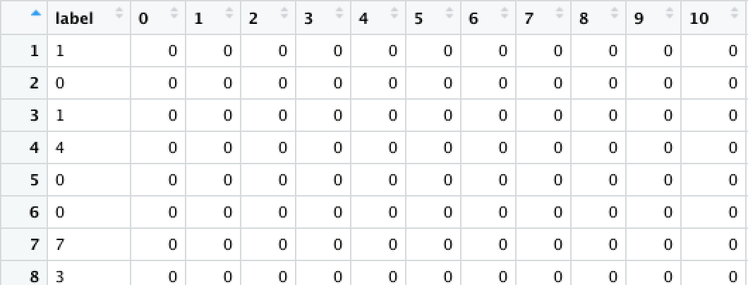

Figure 1

## Data Processing

The training data set has 785 columns. The first column, called "label", is the digit that the user drew. The rest of the columns contain the pixel-values of the associated image. We will remove the "pixel" from the column name, so it will be easy to plot them.

Each pixel column in the training set has a name like pixelX, where x is an integer between 0 and 783, inclusive. To locate this pixel on the image, suppose that we have decomposed x as x = I * 28 + j, where i and j are integers between 0 and 27, inclusive. Then pixelx is located on row I and column j of a 28 x 28 matrix (indexing by zero). We will convert the long-form pixel to 28x28 format to measure the distance from the center.

Figure 2 show the data processing steps

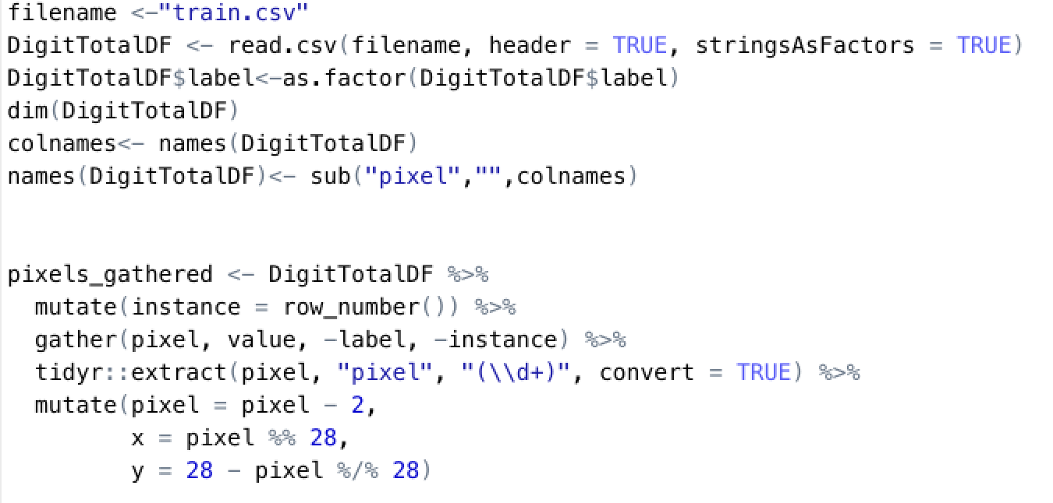

Figure 2

## Exploratory Data Analysis

We will first check how many samples we have for each class of digit. Figure 1 shows the class distribution, where all of the numbers have 4000 samples on average each. We have an excellent classification set on our hand, where each class is well represented, and no one class is underrepresented.

Figure 3

Next, we will look at the pixels themselves, and we will group them by the pixel color. Figure 2 shows the frequency of the colors. Zero indicates blank cell and 255 indicates black, and in between numbers show the grey intensity. More than 80 percent of the cells are empty, and only 20% of the cells are occupied. That gives us roughly 150 pixels to work with on average.

Figure 4

Next, we will check the variance in each digit. We will compute the Euclidean distance for each class and look at the variance. Except for digit one, all of them have acceptable variance, indicating diverse writing styles for each number. All of them have lots of outliers, so we can't drop the outliers for our analysis. And four and nine are going to be problematic, and they have too many outliers.

Figure 5

## Models

### Model Training and Testing Strategy

For all of our models, we will be doing a holdout test and a k-fold cross-validation test. We will split the data into a 60/40 split using the class for the holdout, so we maintain equal separation among the numbers. We will achieve equal division by specifying the response variable as a classification strategy.



For the k-fold cross-validation, we will use 3-fold cross-validation and measure the average accuracy.

### Decision Tree Models

We will start with building a decision tree model with a holdout test. We will begin with the default complexity parameter zero.



Then we will prune the tree to generalize based on the least cross-validated error



Then we will finish with a 3-fold cross-validation test to measure the accuracy.

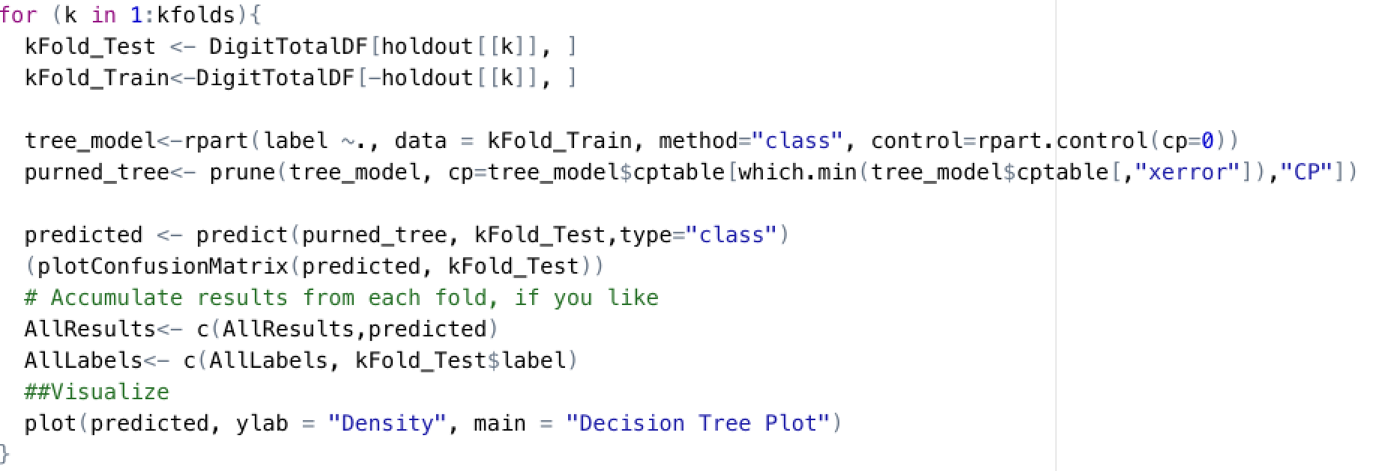

### Naïve Bayes Models

We will then train a Naïve Bayes model for the whole data set and look at the accuracy. We will follow the same text train split we did for the decision tree model.

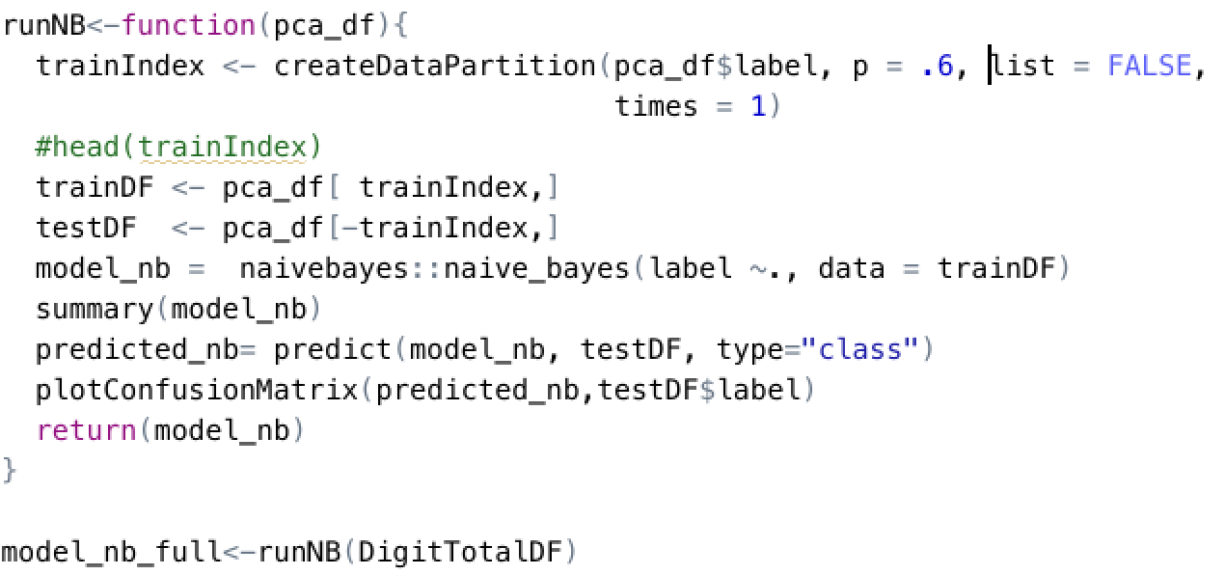

Since Naïve Bayes calculates posterior probabilities, it will end up calculating zero weights due to a large number of empty cells in our image data. So we will do a PCA analysis to pick the top features and retrain the Naïve Bayes model.

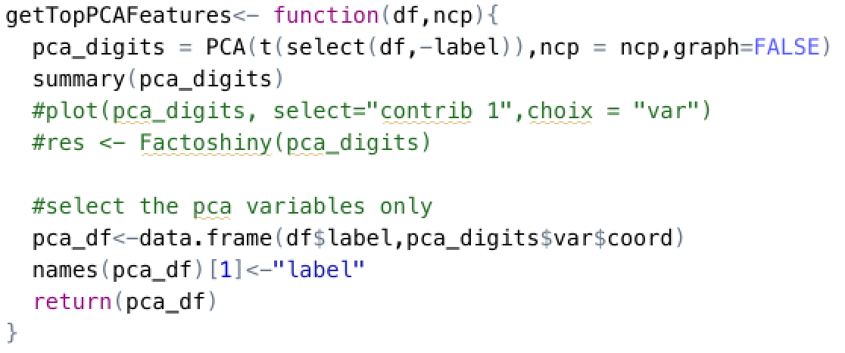

We will run multiple iterations of top PCA features to pick the best parts. We will run from 10 to 150. The 150 is the average pixels we estimated, which will contain the shades.

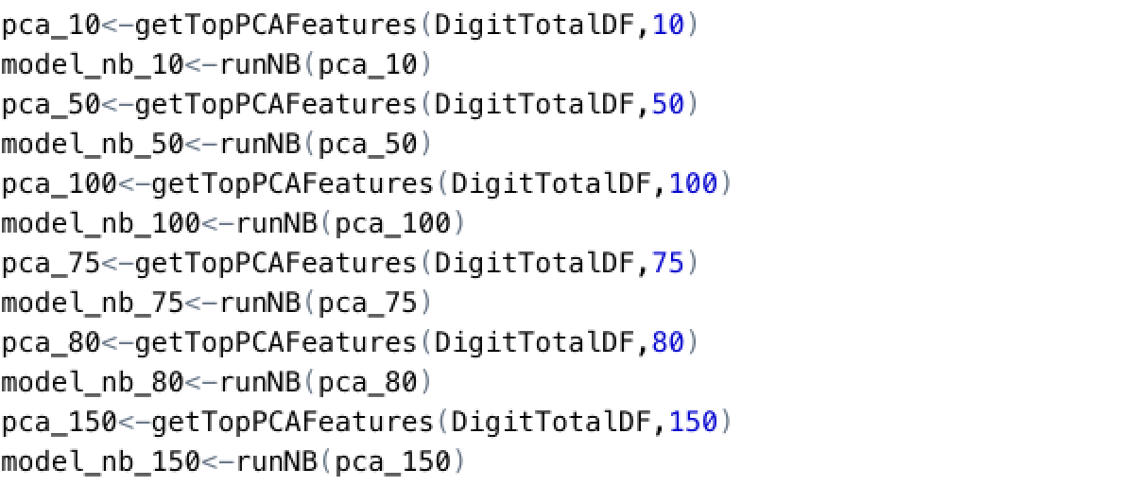

We will finish with 3-fold cross-validation for our best performing PCA model.

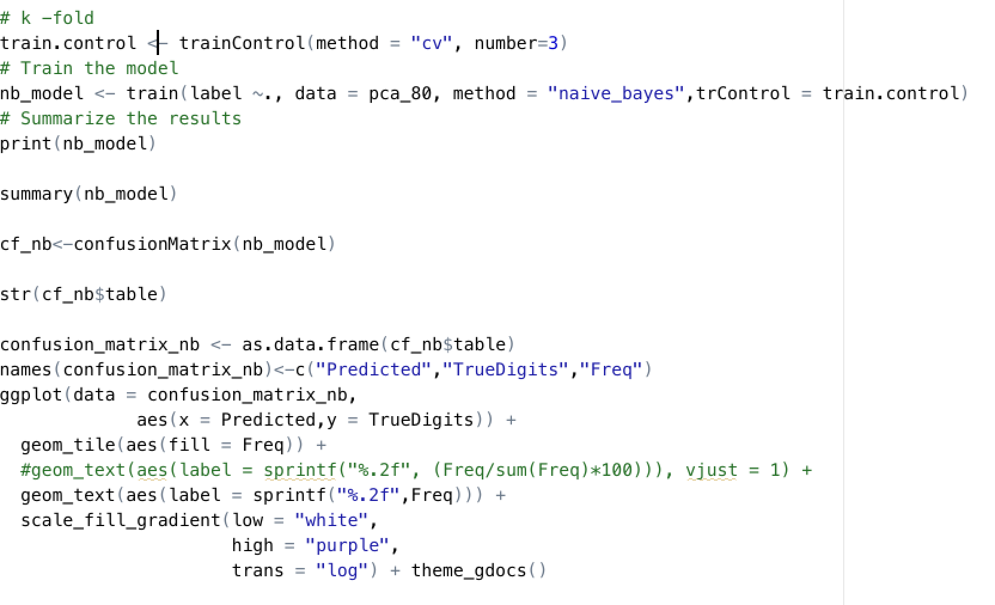

# Results

### Decision Tree Models

The decision tree model's first run gave us an excellent accuracy at 84.7% in the holdout test. It used 455 pixels out of 784 pixels to construct the decision tree, and it appears it used all of the pixels with some value. So it over fit the data. Figure 6 shows the cross-validation error and the complexity parameter concerning the size of the tree. And we might be able to trim at around size 160, which falls in line with the average pixels we estimated to be containing the shades.

|  |  |
| --- | --- |
|  |  |

Figure 6

Figure 7 shows the actual tree, and it is so deep.

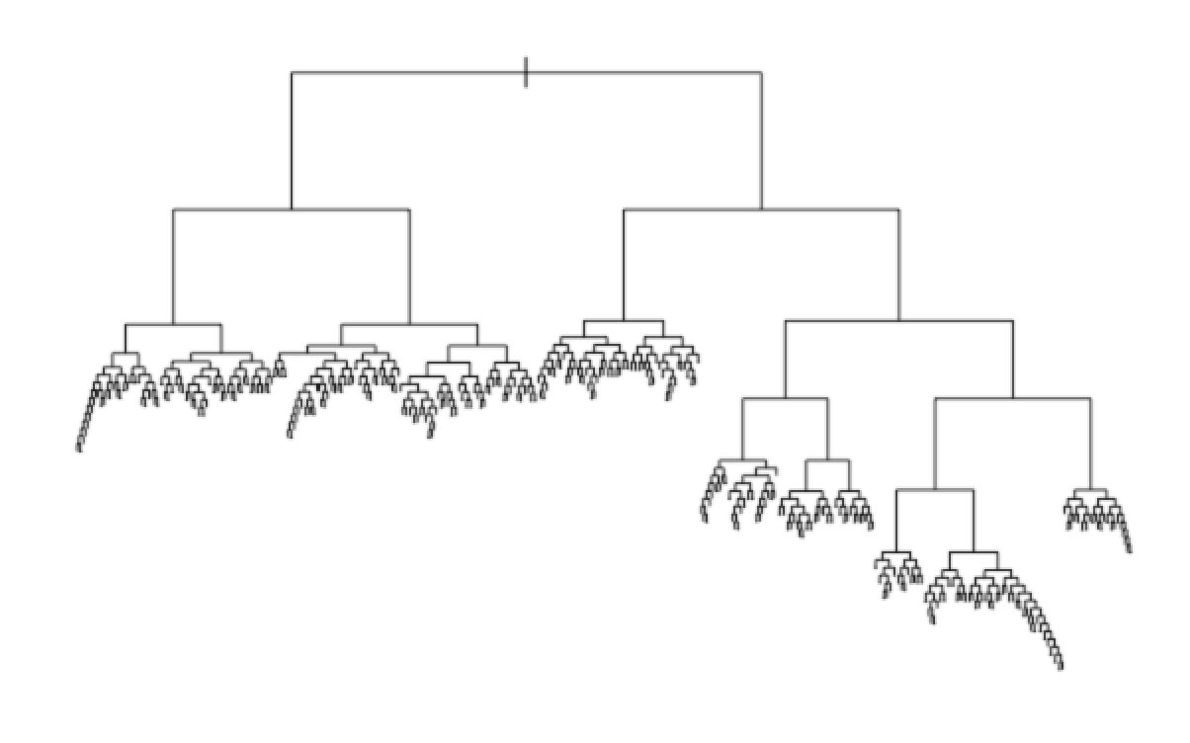

Figure 7

Figure 8 shows the tree's confusion matrix, Numbers 6 and 8 has low scores, and the algorithm has a hard time distinguishing number 5 with number 3 and 8. And also between numbers 4v and 9. It makes sense; they share common features.

Figure 8

The pruned tree gave a little better overall accuracy at 85% on our split test. It still used 228 pixels to decide more than what we estimated, but it might be the actual number of pixels that genuinely captures the variance.

Figure 9

The final cross-validated result also came at 85.06% and did a little better recognizing number five versus number nine. So our overall accuracy from the decision tree model will be at 85% in real life.

Figure 10

### Naïve Bayes Models

Our Naïve Bayes model's first run with all pixels resulted in an accuracy of 52.26%, which is expected given we have a lot of empty pixels. Figure 11 shows the confusion matrix for a model with all the pixel data.

Figure 11

Figure 12 shows the confusion matrix and the Naïve Bayes model's corresponding accuracy with top n PCA features.

PCA is for dimensionality reduction by projecting each data point onto only the first few principal components to obtain lower-dimensional data while preserving as much of the data's variation as possible. The first central component can equivalently be defined as a direction that maximizes the projected data variance.

The top 10 features resulted in 76% accuracy, and 150 resulted in 82% accuracy. But we got the most accurate model at the top 75 features. It resulted in 86.4% accuracy. The model achieved the highest accuracy with just 75-pixel data.

Figure 13 show the 3-fold cross-validation result, which came at 85% accuracy

|  |  |
| --- | --- |
| Top 10 Features. Accuracy: 76.15 | Top 50 Features. Accuracy: 86.89% |
| Top 100 Features, Accuracy: 85.16% | Top 75 Features, Accuracy: 86.4% |
| Top 80 Features, Accuracy: 86.15% | Top 150 Features, Accuracy: 82.17% |

Figure 12

Cross-Validated 3 fold Confusion Matrix, 85% accuracy

### Model Comparison

The decision tree model is more comfortable to develop, and it took less time. The Naive Bayes default model performed poorly, but we achieved a little better result in holdout test for the PCA model, but it took us more time to go through the PCA.

The decision Tree model took time to train since it has to iterate multiple times the training set to do the splits. The Naïve Bayes was quick since it calculates the prior probabilities, which can be achieved in one pass.

### Kaggle Submission

We will predict the test data set with the competition to predict the unlabeled digits and submit them to Kaggle for evaluation. The results are presented below. The decision tree model performed well with real data, and it is very close to our k-fold result. The Naïve Bayes model performed very poorly. Since it only used 75 pixels to predict, it might not be enough; we may have to redo the PCA with a higher dimension.

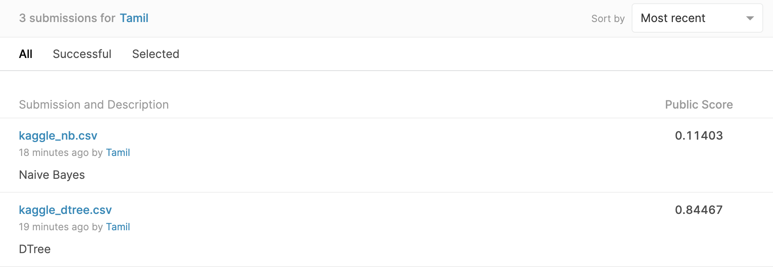

# Conclusions

We explored two statistical methods to recognize the handwritten numbers, which can help identify the numbers in the digitized census surveys. We successfully identified the digits using statistical methods.

We observed the below trends from the people's handwriting.

1. People are writing digits 0,1,2,6, and 7 more similar to each other.
2. People write letters 3,8, and 4, 9 similar to each other because of their structural similarities.
3. And digit 5 has a more diverse writing style.